DESIGN AND ANALYSIS OF ALGORITHMS
ASSIGNMENT 1
Design, Analyse and Validate an Efficient Search Strategy
for a Large-Scale Student Record System

Student details | Fill in before submission
Name | R. Guruprasad
Registration number | 192472094
Course / Section | CSA0617-DAA
GitHub repository | Submitted
Submission date | 24/10/2026

CO1: Algorithm fundamentals, efficiency analysis, asymptotic analysis, mathematical analysis, recurrence analysis, and Master Theorem.
Important: This report is a structured draft based on the uploaded assignment and submission rules. Replace placeholders, use your assigned third algorithm, run the code on your own computer, and insert genuine screenshots and measured results before submission.

Problem Overview
A university stores student records identified by unique registration numbers. The database may grow from 1,000 to 1,000,000 or more records. The system must locate a requested registration number efficiently. This report compares three strategies: Linear Search, Binary Search, and Hash Table Search. Linear and binary search are mandatory in the assignment. Hash-table search is used here as the example third strategy; replace it if your roll-number group has been assigned interpolation, jump/exponential search, or a tree-based method.
Assumptions: registration numbers are unique; binary search operates on a sorted copy of the records; hash-table construction is preprocessing; all algorithms use the same generated registration-number dataset and the same test keys for a fair comparison.

Task 1 – Design the Algorithm

Approach 1: Iterative Linear Search
Idea: examine each registration number from the beginning until the key is found or the list ends. It works on unsorted data and needs no preprocessing.
Pseudocode:
LINEAR_SEARCH(A, key):
for i = 0 to length(A) - 1:
if A[i] == key:
return i
return NOT_FOUND
Preprocessing: none. Justification: it provides a simple baseline and performs well when the dataset is small or the target is near the beginning.

Approach 2: Recursive Binary Search
Idea: binary search checks the middle element of a sorted array. Depending on the comparison, it continues in only the left or right half. The recursive implementation demonstrates a recursive strategy.
Pseudocode:
BINARY_SEARCH(A, key, low, high):
if low > high:
return NOT_FOUND
mid = floor((low + high) / 2)
if A[mid] == key:
return mid
if key < A[mid]:
return BINARY_SEARCH(A, key, low, mid - 1)
else:
return BINARY_SEARCH(A, key, mid + 1, high)
Preprocessing: sort the records first, at cost O(n log n), unless the database is already sorted. Justification: it reduces each search to half the remaining search range.

Approach 3: Hash Table Search
Idea: build a dictionary that maps each registration number to its record or index. A lookup usually takes expected constant time, although collisions can make the worst case linear.
Pseudocode:
BUILD_HASH(A):
H = empty hash table
for each record x in A:
H[x.registration_number] = x
return H

HASH_SEARCH(H, key):
if key exists in H:
return H[key]
return NOT_FOUND
Preprocessing: construct the hash table in expected O(n) time and O(n) additional space. Justification: the database changes only once per day, while searches are frequent, so one-time index construction can be amortized across many lookups.

Task 2 – Identify the Basic Operation
Algorithm | Basic operation | Where it occurs | Why it matters
Linear Search | Compare A[i] with key | Inside the loop for each examined element | Number of comparisons grows with the position of the key or with n if absent.
Recursive Binary Search | Compare key with A[mid] | At each recursive call | The active interval is halved, so the number of comparisons grows logarithmically.
Hash Table Search | Compute hash / compare key within bucket | During insertion and lookup | Expected lookup is O(1) with a suitable hash distribution; collisions can increase comparisons.

Task 3 – Mathematical Time-Complexity Derivation

Linear Search
Let n be the number of records. If the key is at zero-based index k, the algorithm performs k + 1 comparisons. If the key is absent, it performs n comparisons. Thus T(n) = c0 + c1·C(n), where C(n) is the number of key comparisons. Best case: C(n)=1. Worst case: C(n)=n. If a successful key is equally likely to be at any of the n positions, the average successful comparison count is (1+2+…+n)/n = n(n+1)/(2n) = (n+1)/2. Therefore average and worst search time are Θ(n). Preprocessing cost is zero.

Binary Search
Each comparison reduces the search interval from n elements to at most n/2, then n/4, and so on. After k steps, the interval size is at most n/2^k. Stop when it is at most 1: n/2^k ≤ 1, so 2^k ≥ n and k ≥ log₂ n. The number of comparisons is Θ(log n). If the input is unsorted, sorting costs Θ(n log n); the total cost for one query is Θ(n log n) + Θ(log n) = Θ(n log n). If sorted data is already maintained, each lookup costs Θ(log n).

Hash Table Search
Building a hash table inserts n records. With expected O(1) insertion per record, preprocessing is expected Θ(n). For q searches, expected search work is Θ(q), so total expected work is Θ(n+q). For one lookup after building the table, expected cost is Θ(1). In the worst case, many keys may collide into one bucket; a lookup can then cost Θ(n), and building can also degrade depending on the implementation.
Approach | Preprocessing | One search (best) | One search (average/expected) | One search (worst)
Linear Search | Θ(1) | Θ(1) | Θ(n) | Θ(n)
Binary Search | Θ(n log n) if sorting is needed | Θ(1) | Θ(log n) | Θ(log n)
Hash Table | Expected Θ(n) | Θ(1) | Expected Θ(1) | Θ(n)

Task 4 – Best, Average and Worst Cases
Algorithm | Best-case condition | Average-case condition | Worst-case condition
Linear Search | Key is first; 1 comparison | Key position is distributed through list; about (n+1)/2 comparisons for successful search | Key is last or absent; n comparisons
Binary Search | Key is at the middle on first check; 1 comparison | Search interval repeatedly halves; Θ(log n) comparisons | Key absent or reached at deepest level; Θ(log n) comparisons
Hash Table | Key hashes to an available bucket with no collision | Good hash distribution and controlled load factor; expected O(1) lookup | Many collisions; lookup may inspect Θ(n) entries

The cases differ because linear search can inspect a growing prefix, binary search discards half the candidates per comparison, and hash-table performance depends on how evenly keys are distributed among buckets.

Task 5 – Asymptotic Analysis
Algorithm / operation | Big-O upper bound | Big-Ω lower bound | Big-Θ tight bound
Linear search, worst case | O(n) | Ω(n) | Θ(n)
Binary search, worst case | O(log n) | Ω(log n) | Θ(log n)
Hash lookup, expected | O(1) expected | Ω(1) | Θ(1) expected
Hash lookup, worst case | O(n) | Ω(1) | Worst-case upper bound O(n); exact bound depends on collision pattern
Sort before binary search | O(n log n) | Ω(n log n) for comparison sorting | Θ(n log n) for standard comparison sort

As the database grows from 1,000 to 1,000,000 records, linear search can require roughly 1,000 times as many comparisons in the worst case. Binary search grows by about log₂(1,000,000)/log₂(1,000) ≈ 2 times the logarithmic comparison count, while expected hash lookup remains approximately constant after preprocessing. Actual elapsed time depends on implementation, hardware, cache behaviour, and data structure overhead.

Task 6 – Formulate the Recurrence Relation
For recursive binary search, a problem of size n makes one recursive call on at most half the elements and performs constant work to compute the middle and compare the key.
T(n) = T(⌊n/2⌋) + c, for n > 1
T(1) = d
Components: original input size is n; subproblem size is approximately n/2; there is one recursive call; work outside the call is constant; the base case occurs when the interval is empty or has one element.

Task 7 – Solve the Recurrence Relation
Using iteration, assume T(n) = T(n/2) + c.
T(n) = T(n/2) + c
= T(n/4) + 2c
= T(n/8) + 3c
= T(n/2^k) + kc
The recursion stops when n/2^k ≤ 1, so k ≥ log₂ n. At the stopping point, T(1)=d. Therefore T(n)=d+c·⌈log₂ n⌉, which is Θ(log n). Iteration is applicable because each recursive step reduces the problem size by approximately half and adds constant work.

Task 8 – Implement and Test the Algorithms
The following Python code implements all three approaches and includes reproducible dataset generation. For personalisation, use the last four digits of your registration number as the random seed, and test your registration number (present) and registration number + 1 (absent) as required by the submission rules.
import random
import time
import csv

def linear_search(data, key):
comparisons = 0
for i, value in enumerate(data):
comparisons += 1
if value == key:
return i, comparisons
return -1, comparisons

def binary_search_recursive(data, key, low=0, high=None, counter=None):
if high is None:
high = len(data) - 1
if counter is None:
counter = [0]
if low > high:
return -1, counter[0]
mid = (low + high) // 2
counter[0] += 1
if data[mid] == key:
return mid, counter[0]
if key < data[mid]:
return binary_search_recursive(data, key, low, mid - 1, counter)
return binary_search_recursive(data, key, mid + 1, high, counter)

def build_hash(data):
return {value: i for i, value in enumerate(data)}

def hash_search(table, key):
# Python dict lookup does not expose internal key-comparison counts.
start = time.perf_counter()
result = table.get(key, -1)
elapsed = time.perf_counter() - start
return result, elapsed

def make_dataset(n, seed):
rng = random.Random(seed)
return rng.sample(range(1, 10*n + 1), n)

def run_tests(reg_no, seed):
sizes = [1_000, 10_000, 100_000, 1_000_000]
with open('results.csv', 'w', newline='') as f:
writer = csv.writer(f)
writer.writerow(['n','algorithm','case','found','index','comparisons','seconds'])
for n in sizes:
data = make_dataset(n, seed)
sorted_data = sorted(data)
hash_table = build_hash(data)
tests = [('found', reg_no), ('not_found', reg_no + 1)]
# Add the required found key to the dataset if it is not present, then rebuild.
if reg_no not in data:
data[0] = reg_no
sorted_data = sorted(data)
hash_table = build_hash(data)
for case, key in tests:
for name, fn, arr in [('linear', linear_search, data),
('binary', binary_search_recursive, sorted_data)]:
t0 = time.perf_counter()
idx, comps = fn(arr, key)
elapsed = time.perf_counter() - t0
writer.writerow([n, name, case, idx != -1, idx, comps, f'{elapsed:.8f}'])
t0 = time.perf_counter()
idx, _ = hash_search(hash_table, key)
elapsed = time.perf_counter() - t0
writer.writerow([n, 'hash', case, idx != -1, idx, 'not exposed', f'{elapsed:.8f}'])
print(f'Completed dataset size: {n}')
print('Saved measurements to results.csv')

if __name__ == '__main__':
reg_no = int(input('Enter your registration number: '))
seed = int(input('Enter last 4 digits of registration number: '))
run_tests(reg_no, seed)
Implementation note: the test harness above is a starting point. Before using it, ensure the 'not found' test key is actually absent from the generated data (reg_no + 1 can randomly appear in a generated range). If it appears, replace that key with a guaranteed absent integer such as max(data) + 1. Also, for a fair benchmark, time hash-table construction separately from query time and record preprocessing time in the results.

Correctness Test Cases
Test | Key | Expected outcome
Present key | A registration number included in the dataset | Found
Absent key | A number guaranteed not to occur in the dataset | Not found
Smallest dataset | n = 1,000 | All three approaches return consistent found/not-found results
Largest dataset | n = 1,000,000 | All three approaches return consistent found/not-found results

Evidence to add: capture full terminal or IDE screenshots for each algorithm and dataset size. Each screenshot must show your name or registration number and system date/time. Do not fabricate output or screenshots.

Task 9 – Record Experimental Performance
Run the code on your own machine and use the generated CSV to prepare a table for n = 1,000, 10,000, 100,000, and 1,000,000. The assignment requires real measurements and graphs, so the table below is a recording template rather than invented experimental data.
n | Algorithm | Case | Comparisons | Preprocessing time (s) | Search time (s)
1,000 | Linear | Found / absent | [measure] | 0 | [measure]
1,000 | Binary | Found / absent | [measure] | [sort time] | [measure]
1,000 | Hash table | Found / absent | Not exposed by Python dict | [build time] | [measure]
10,000 | Repeat all three | Found / absent | [measure] | [measure] | [measure]
100,000 | Repeat all three | Found / absent | [measure] | [measure] | [measure]
1,000,000 | Repeat all three | Found / absent | [measure] | [measure] | [measure]

Create labelled graphs from your own results.csv: (1) input size versus search time, (2) input size versus comparison count where available, and (3) hash-table build time versus input size. Include a caption for each graph and retain the CSV in the repository.

Task 10 – Compare Theory with Experiment
Expected theoretical trend: linear search time and comparisons increase proportionally with n for absent keys and late-position keys. Binary search comparisons grow logarithmically, but sorting an unsorted dataset adds an O(n log n) preprocessing cost. Hash tables require O(n) expected preprocessing and additional memory, then provide expected O(1) lookups.
When discussing your measurements, state whether each trend is visible in your own graphs. Measured times may differ from theoretical growth because of interpreter overhead, memory allocation, CPU cache effects, operating-system scheduling, sorting cost, hash-table resizing, and timer resolution. Do not claim that experimental results prove a complexity by themselves; use them alongside the mathematical analysis.
Insert your evidence-based observations here after running the benchmark: [Describe the fastest method for each n, explain whether preprocessing was included, and refer to your actual graph/table values.]

Task 11 – Recommend and Defend the Final Design
Recommendation: use a hash table or hash-based index for repeated registration-number lookups when records are updated only once per day, provided sufficient memory is available and the implementation handles collisions correctly. Build or refresh the index after daily updates, then use it for incoming searches. Expected index construction is O(n), expected lookup is O(1), and the index consumes O(n) additional space.
Binary search is a strong alternative when records can be maintained in sorted order and memory overhead should be lower; it provides O(log n) lookup, but maintaining sorted data or sorting before queries has a cost. Linear search is simplest and requires no preprocessing, but its O(n) lookup cost makes it unsuitable as the primary strategy for one million records and frequent searches.
This recommendation must be defended using the student's measured results. Add your own values and refer to the corresponding graphs before final submission.

Task 12 – Day-4 Design Challenge

A. Impact Analysis
The updated workload is 50,000 search requests per hour against 1,000,000 records, while new records are added only once per day. Searches are frequent relative to updates. Therefore, it is worthwhile to spend time building an index once and reuse it for many queries. The design should also consider memory, concurrent access, duplicate handling, and the time required to refresh the index after updates.

B. Evaluation of the Original Design
Linear search can require up to 1,000,000 comparisons per absent query; at 50,000 queries per hour, this can produce an impractically large number of comparisons. Binary search requires around log₂(1,000,000) ≈ 20 levels per query after sorting. Hash-table lookup is expected O(1), and its O(n) construction cost is amortized across many queries. Since updates are daily, index maintenance is likely manageable, but this must be confirmed with measured build and lookup times.

C. Adaptation or Redesign
Redesign the retrieval path around a hash-based index keyed by registration number. Load the daily record set, validate uniqueness, build the index, and publish the refreshed index atomically. For each query, compute the key lookup and return the record if present. Keep the source data as the authoritative dataset and rebuild or update the index after the daily import.
Daily update: validate records -> build/refresh hash index -> verify index -> publish index
Each request: receive registration number -> lookup in index -> return record or NOT_FOUND
Complexity: expected O(n) to build the index and expected O(1) per search; O(n) additional space. A hash table has O(n) worst-case lookup under severe collisions, so use a robust implementation and monitor load factor and lookup latency.

D. Evidence-Based Defence
The redesign is justified by the ratio of many searches to relatively infrequent updates. The mathematical model predicts O(1) expected lookup after O(n) preprocessing, while binary search offers O(log n) lookup and linear search O(n). To complete the defence, benchmark at least 50,000 searches on a 1,000,000-record dataset, report total and average query time, include index construction time separately, and attach terminal output and graphs. Use only measurements produced on your own machine.

Final Conclusion
The analysis shows that the appropriate search strategy depends on dataset size, update frequency, memory, and query volume. Linear search is useful as a baseline, recursive binary search is efficient on sorted data, and a hash-based index is a suitable candidate for frequent registration-number retrieval when updates are infrequent. The final submission should include personal dataset generation, verified experimental results, labelled graphs, screenshots, and a GitHub repository as required by the supplied submission rules.

Submission Checklist
- Fill in name, registration number, course details, date, and GitHub repository URL.
- Confirm the third algorithm assigned to your roll-number group and replace hash-table sections if required.
- Use the last four digits of your registration number as the dataset seed.
- Include registration number (found) and registration number + 1 (not found), ensuring the absent key is truly absent.
- Run all algorithms on 1K, 10K, 100K, and 1M records.
- Generate results.csv and labelled graphs from your own runs.
- Insert full screenshots showing name/registration number and system date/time.
- Create a README, code files, data/generator script, results, screenshots, and at least five meaningful Git commits.
- Export the final report to PDF and upload the PDF, code ZIP, and GitHub link to Google Classroom.

Additional Detailed Notes and Evidence Guide
This expanded section adds practical explanations and screenshot examples. The image previews below are illustrative layouts only; they are not screenshots from your computer and must not be submitted as evidence of your own execution. Follow the instructions under each figure to capture genuine screenshots after running the code.

1. Important Implementation Details
A fair comparison must separate preprocessing from lookup. Linear search can use the original unsorted list. Binary search requires sorted data, so record sorting time separately and decide whether the system sorts once and reuses the sorted list or sorts before every query. A hash table also needs to be built; measure the build time separately from the lookup time.
Use the same dataset and the same keys for all three approaches. For a successful search, select a registration number that is definitely in the dataset. For an unsuccessful search, select a value that is definitely absent. Do not assume registration number + 1 is absent unless you check it.
For reproducible measurements, use time.perf_counter(), run each benchmark several times, and report the median or average. Avoid printing inside the timed section because console output can dominate execution time. Report the computer/software environment and whether preprocessing is included.

2. More Detailed Comparison
Criterion | Linear search | Binary search | Hash table
Input order | Works on unsorted data | Requires sorted data | No sorted order required
Preprocessing | None | Sort once if needed | Build index once
Expected lookup | O(n) | O(log n) | O(1)
Worst lookup | O(n) | O(log n) | O(n) with severe collisions
Extra memory | Very low | Low, apart from sorting/copy | O(n) for index
Suitable when | Small lists or few queries | Ordered data, lower index overhead | Many repeated lookups and infrequent updates

3. Sample Screenshot 1 — Correctness Test
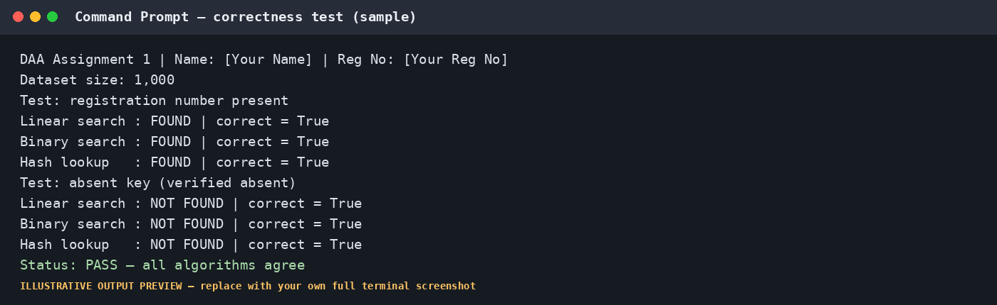
Figure A. Illustrative correctness-output preview. Replace this preview with a full screenshot of your own terminal showing your name/registration number, system date/time, and correct results.
How to capture your own: open VS Code Terminal or PowerShell, navigate to the project folder, run the test script, and take a screenshot that includes the command, output, your identifying line, and visible system date/time. Do not crop away required context.

4. Sample Screenshot 2 — Benchmark Run
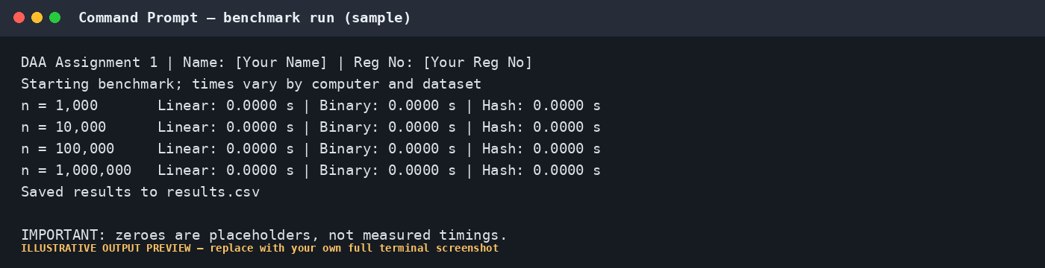
Figure B. Illustrative benchmark-output layout only. The zero timing values are placeholders and are not results.
For your real benchmark, print the actual dataset size, algorithm, case, comparison count where available, preprocessing duration, and search duration. Save each run to CSV so the table and graphs can be reproduced.

5. Sample Graph — Theoretical Growth
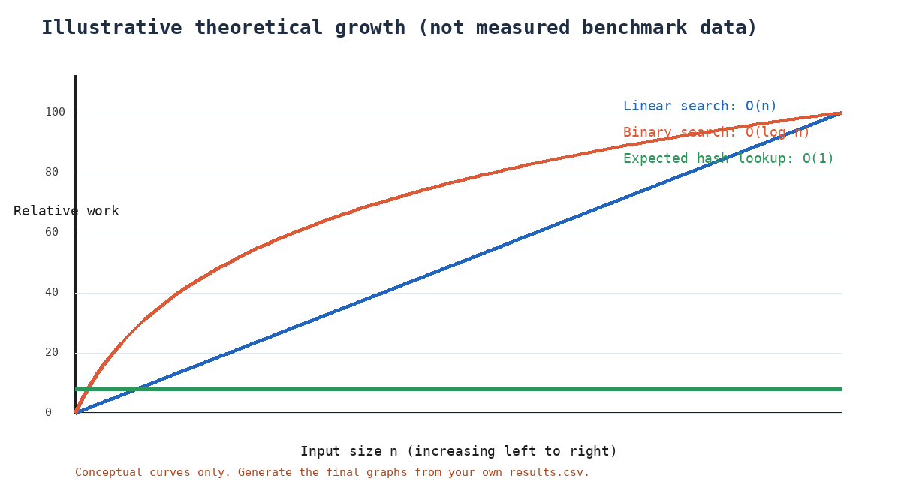
Figure C. Conceptual complexity curves, included to explain expected growth. This is not an experimental graph and should not replace the graphs generated from your own CSV measurements.
For the required experimental graphs, use the actual results.csv file. Label the horizontal axis 'Input size n' and the vertical axis with the measured quantity, such as 'Search time (seconds)' or 'Number of comparisons'. Include a legend and a descriptive figure caption.

6. Suggested Benchmark Procedure
- Generate one dataset for each size: 1,000; 10,000; 100,000; and 1,000,000 records, using the required seed.
- Choose one present key and one verified absent key for every dataset.
- Measure the cost of sorting and hash-table construction separately.
- Run each lookup several times and record the median or average time.
- Count comparisons for linear and binary search. Python's built-in dictionary does not expose its internal comparison count, so record hash lookup time instead.
- Write results to CSV and create labelled graphs from that CSV.
- Capture full screenshots for each required dataset size, including the terminal/IDE, name or registration number, and system date/time.
- Check that every number in the report agrees with the CSV and screenshots.

7. Additional Discussion for the Final Recommendation
The changed workload contains 50,000 searches per hour and only one daily update cycle. If the index is built once and reused, the one-time preprocessing cost is distributed across many searches. For a hash index, expected total work is O(n + q) for building and then serving q lookups, assuming a good hash distribution. For a sorted array, sorting is O(n log n), followed by O(q log n) lookup work. Linear search can require O(qn) comparisons for q unsuccessful or late-position searches.
The hash-table recommendation is conditional rather than absolute: memory use, worst-case collision behaviour, concurrency, record integrity, and measured performance must be considered. If memory is constrained or the records are already maintained in sorted order, binary search may be the more appropriate choice. Use your own benchmark results to make the final decision.

8. Final Evidence Checklist
☐ The report includes all 12 tasks in the order specified by the assignment.
☐ The chosen third algorithm matches the roll-number group allocation.
☐ Dataset seed is the last four digits of the registration number.
☐ Registration number is tested as present and registration number + 1 is tested as absent after verifying absence.
☐ Genuine run screenshots exist for 1K, 10K, 100K, and 1M datasets.
☐ Each screenshot shows name/registration number and system date/time.
☐ CSV values, tables, graphs, and discussion agree with one another.
☐ The report includes the GitHub link and the repository contains reproducible code and README instructions.

